**Shrija Chavan**

**A20381511**

**ITMD 521**

**Week 02**

**Week-03-Analysis**

Below is a brief explanation of the amount of time required in seconds to run each dataset using the awk script, java, and MapReduce (with MaxTemperature and MaxTempetarureWithCombiner) with a graph and chart combined with some screen shots to explain the process in details and compare the time taken by each dataset.

**Chart:**

|  |  |  |  |  |
| --- | --- | --- | --- | --- |
| **Datasets** | **awk** | **java** | **MapReduce** | |
| **MaxTemperature** | **MaxTemperatureWithCombiner** |
| 1990 | 13.62 | 57 | 54 | 49 |
| 1990& 1992 | 99.28 | 382 | 349 | 322 |
| 1990-1993 | 192.40 | 708 | 648 | 610 |

**Graph:**

**Green: 1990 Dataset, Blue: 1990&92 Dataset, Red: 1990-93 Dataset**

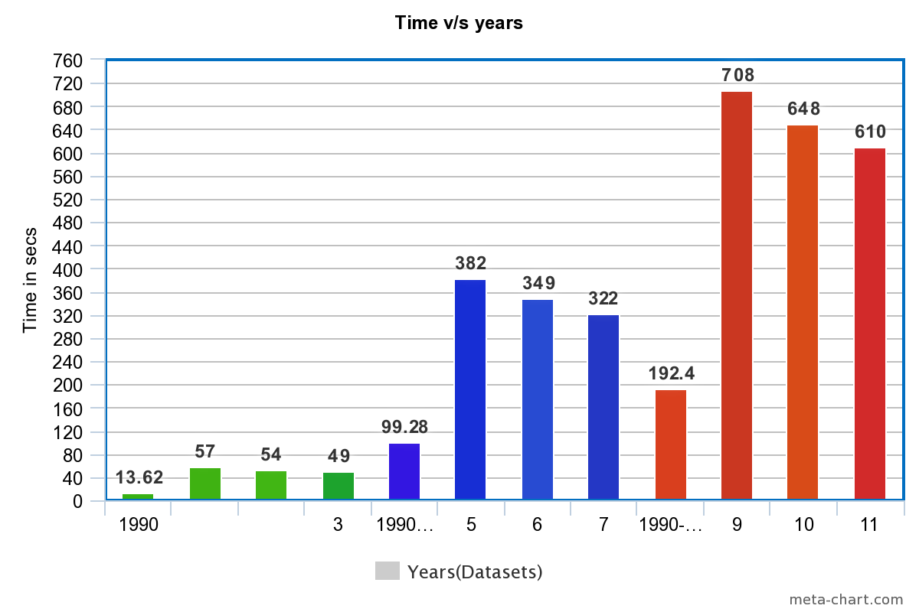

**Analysis:**

As you can see in the above graph and chart that the least time taken to execute the job was by the awk script on the datasets. But, as we observe, after awk script the next minimum time taken was by the MapReduce as compared to Java.

Advantages of using MapReduce over SQL:

MapReduce is one of the efficient programming model to process a large set of data. It works on a key-value pair and can be written in any language. It can be tested on a local cluster or a distributed cluster. The job of the map is to collect the raw data as input and process it in key-value pairs and pass it as an input to the reducer. Generally, the input data will be in the HDFS file system. The reducer will then combine the key-value pair to produce the final results. As the name indicates the reduce job is always performed after the map job.

The Mapper breaks down the large dataset into several small files and distributes it to various data nodes. The data nodes will then process the data and gives the highest temperature per file back to the mapper. The mapper passes the same information to reducer and the reducer will then give you the highest temperature each year. The real preferred standpoint of MapReduce is that it is easy to scale data processing over various computing node as compared to the java which runs on a signal file at a time to give us the result.

MapReduce is also known as the Batch query processor. It has the ability to run adhoc query against the whole dataset and get the results in a reasonable time.

But, there are some scenarios where MR will not be a best choice to choose:

1. When querying small dataset, it will always be preferred to run the job on a single cluster than on a distributed cluster.
2. When you need fast response, MR is not the best choice as its not know to gets the results faster than the SQL.
3. Implementing MR to every job can be costlier, only big companies can afford the resources.
4. Works best on large datasets as compared to small datasets.

**Screen Shots:**

**Using MaxTemperature**

**1990 Dataset**

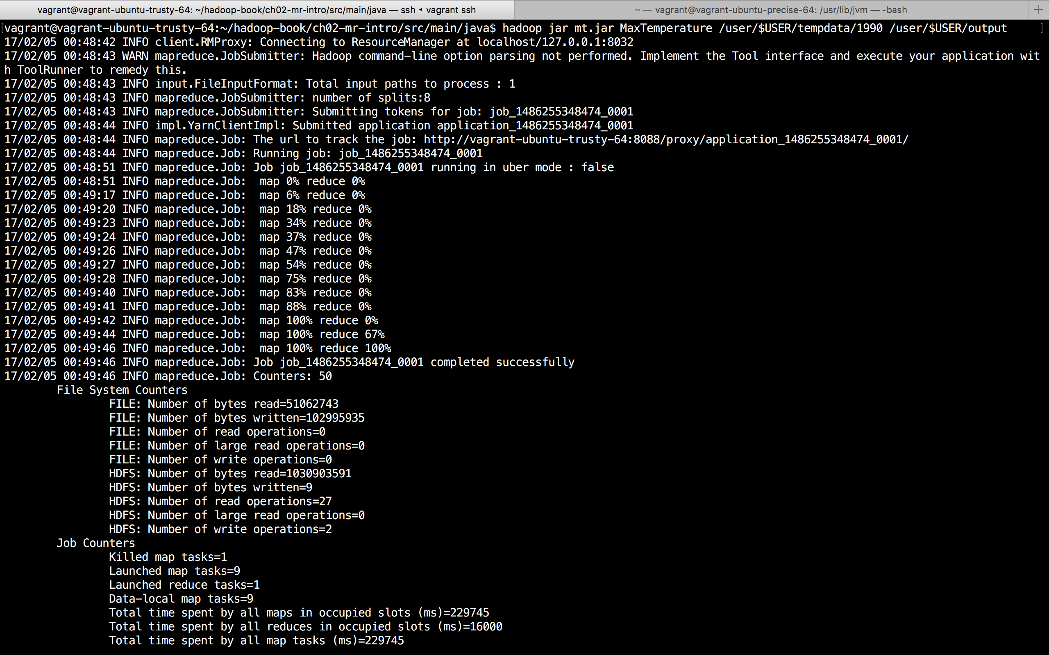

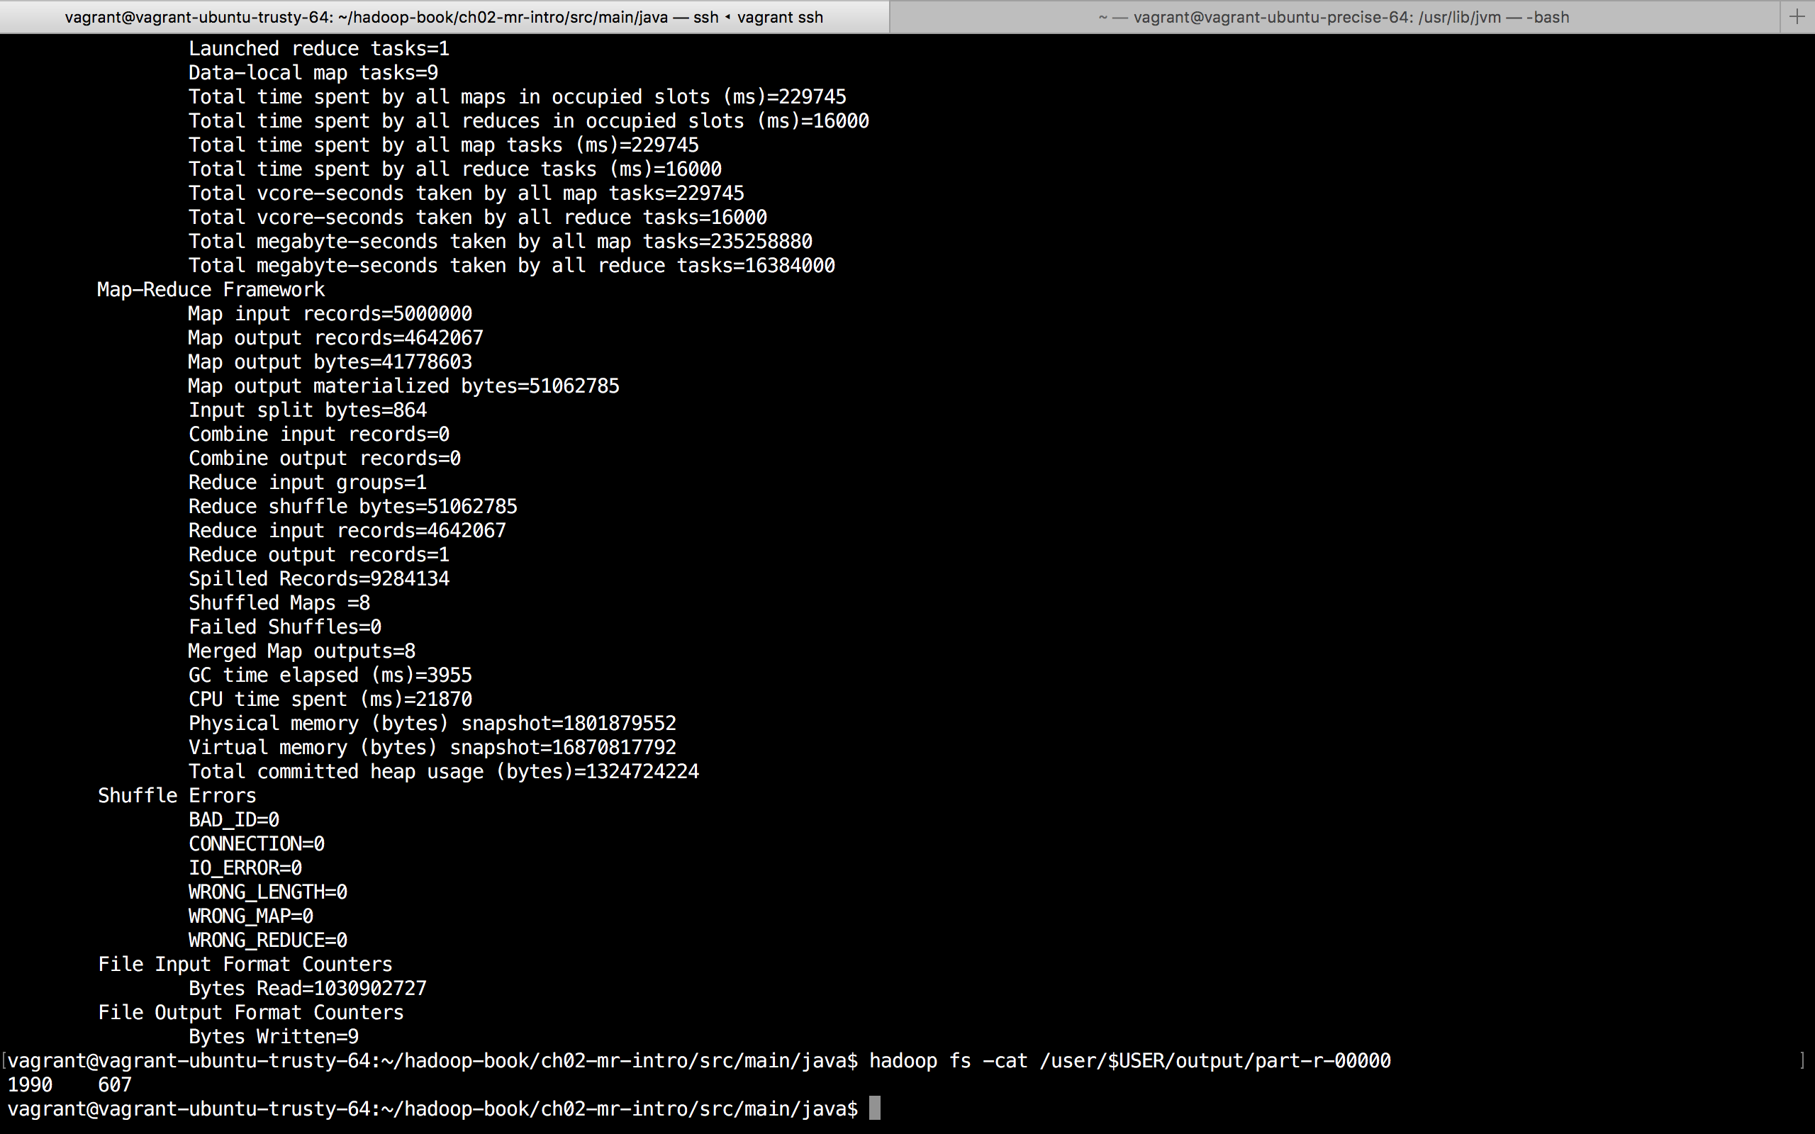

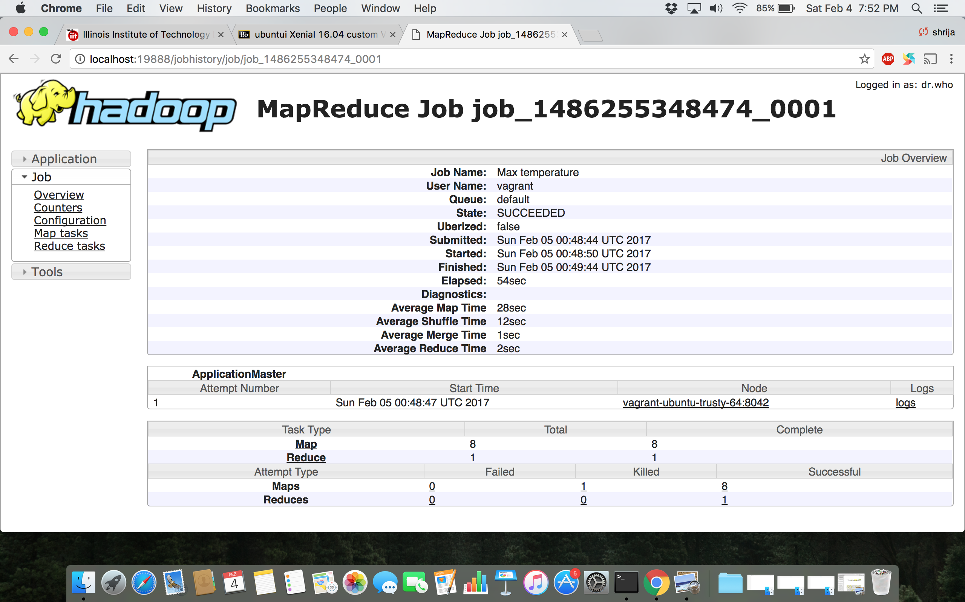

**1990 and 1992 Dataset**

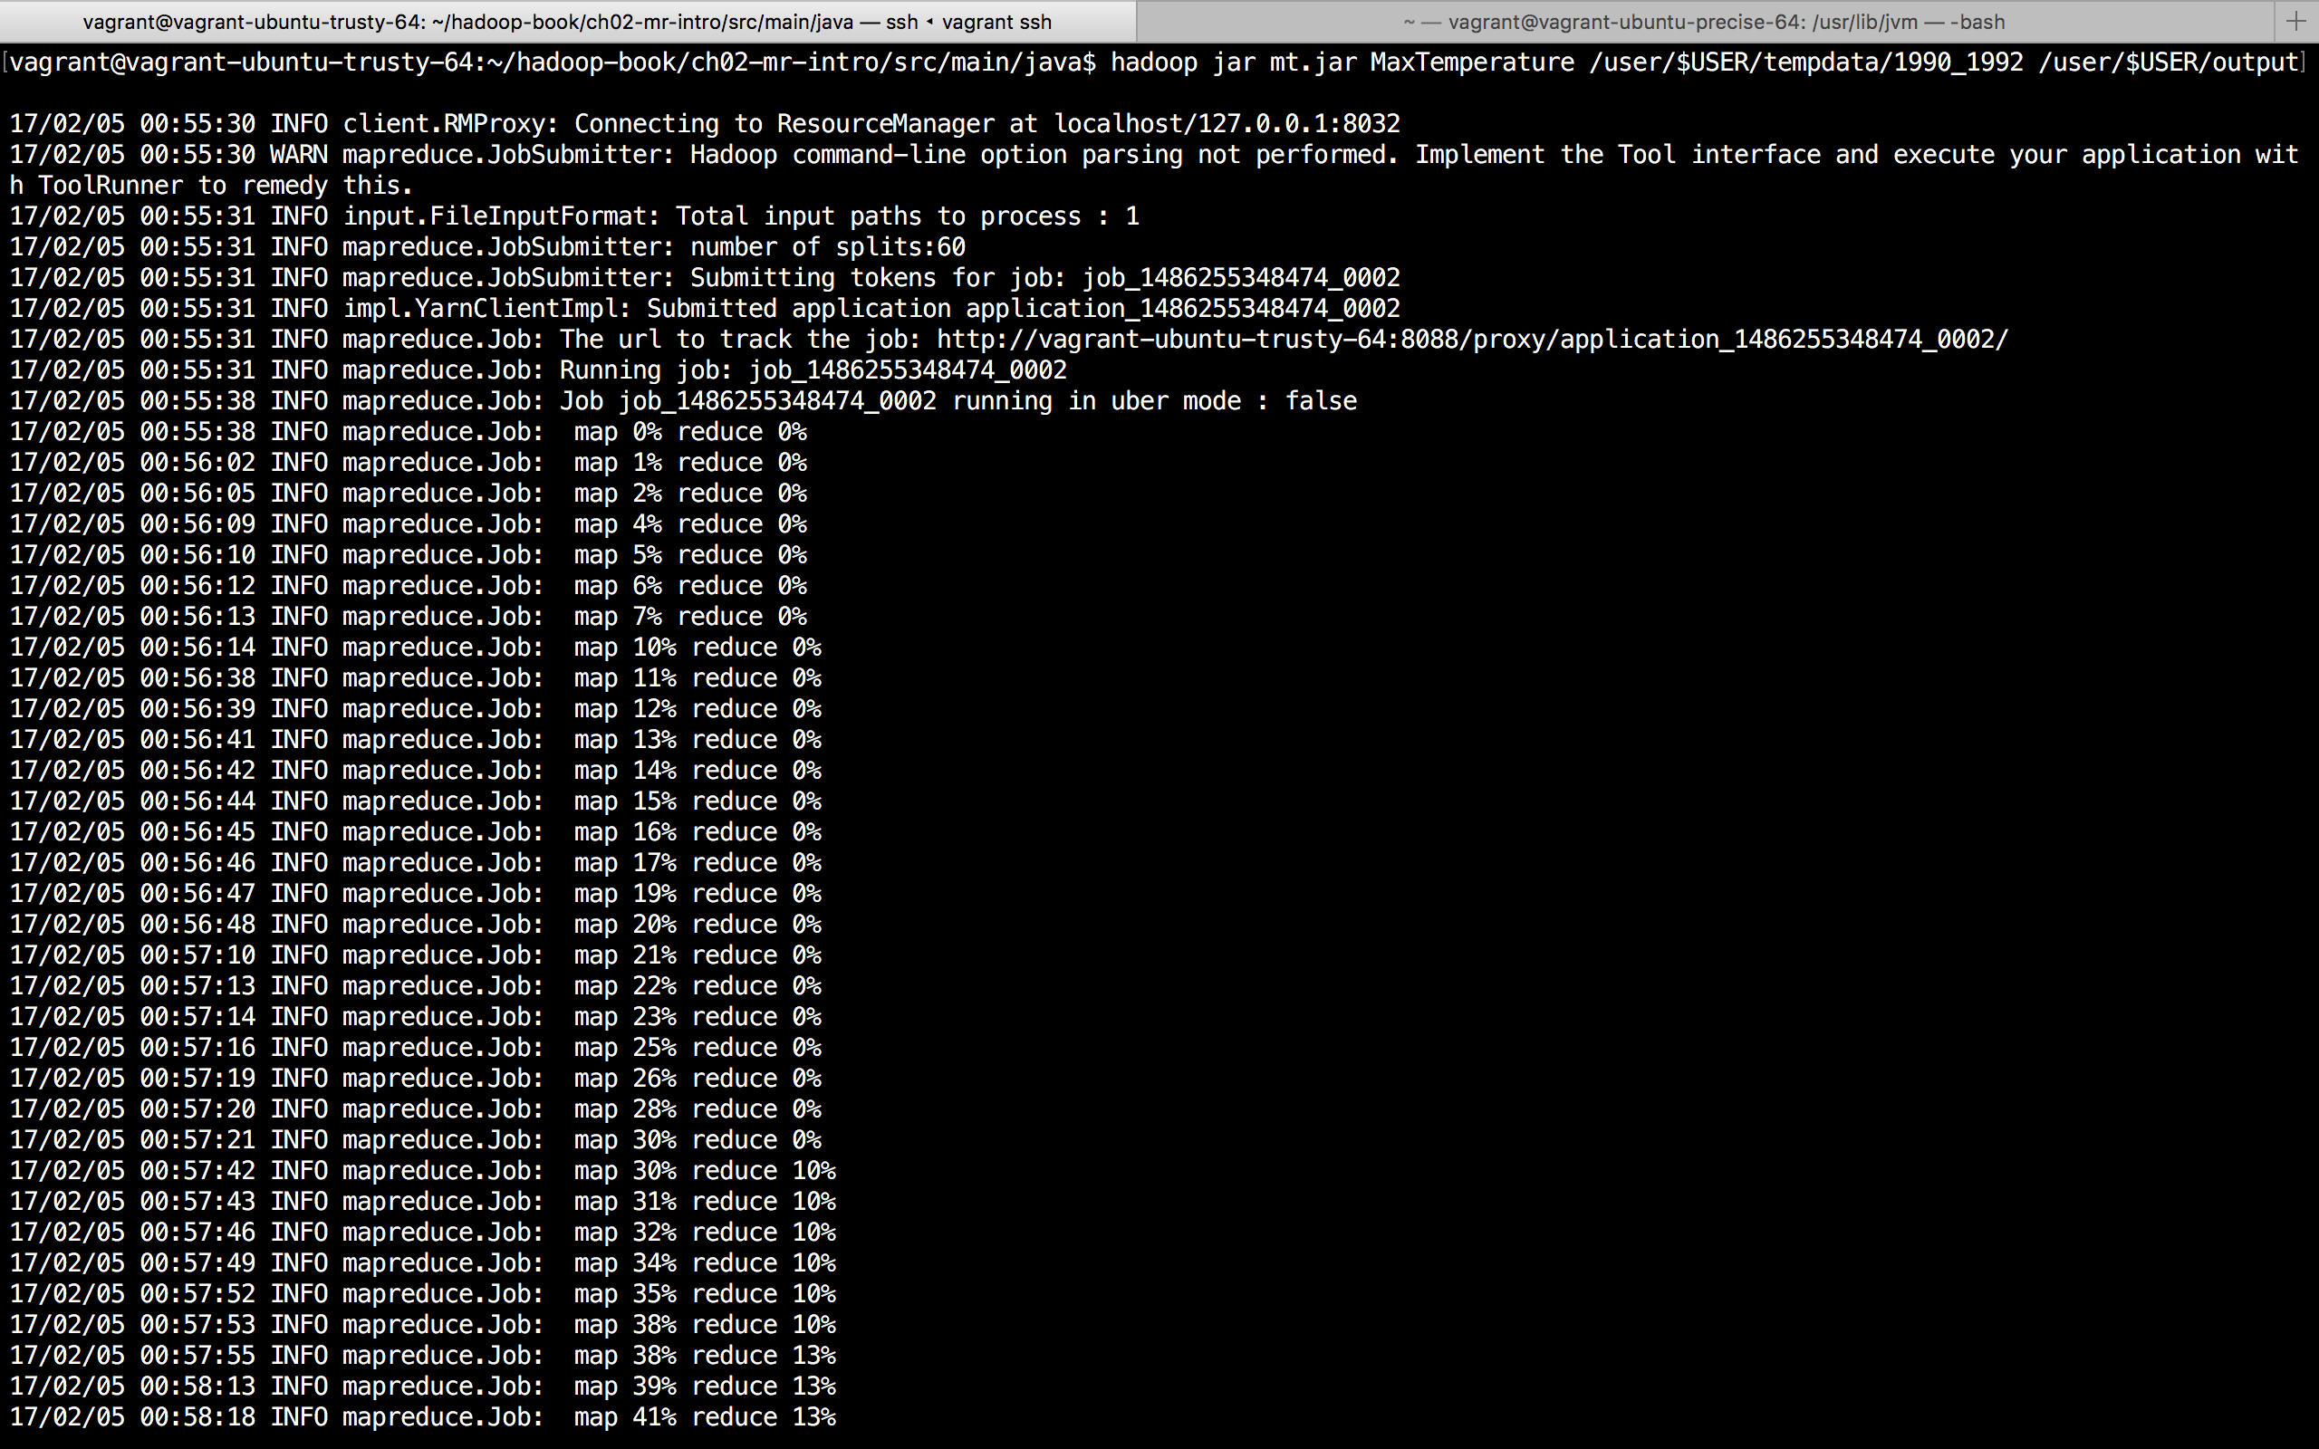

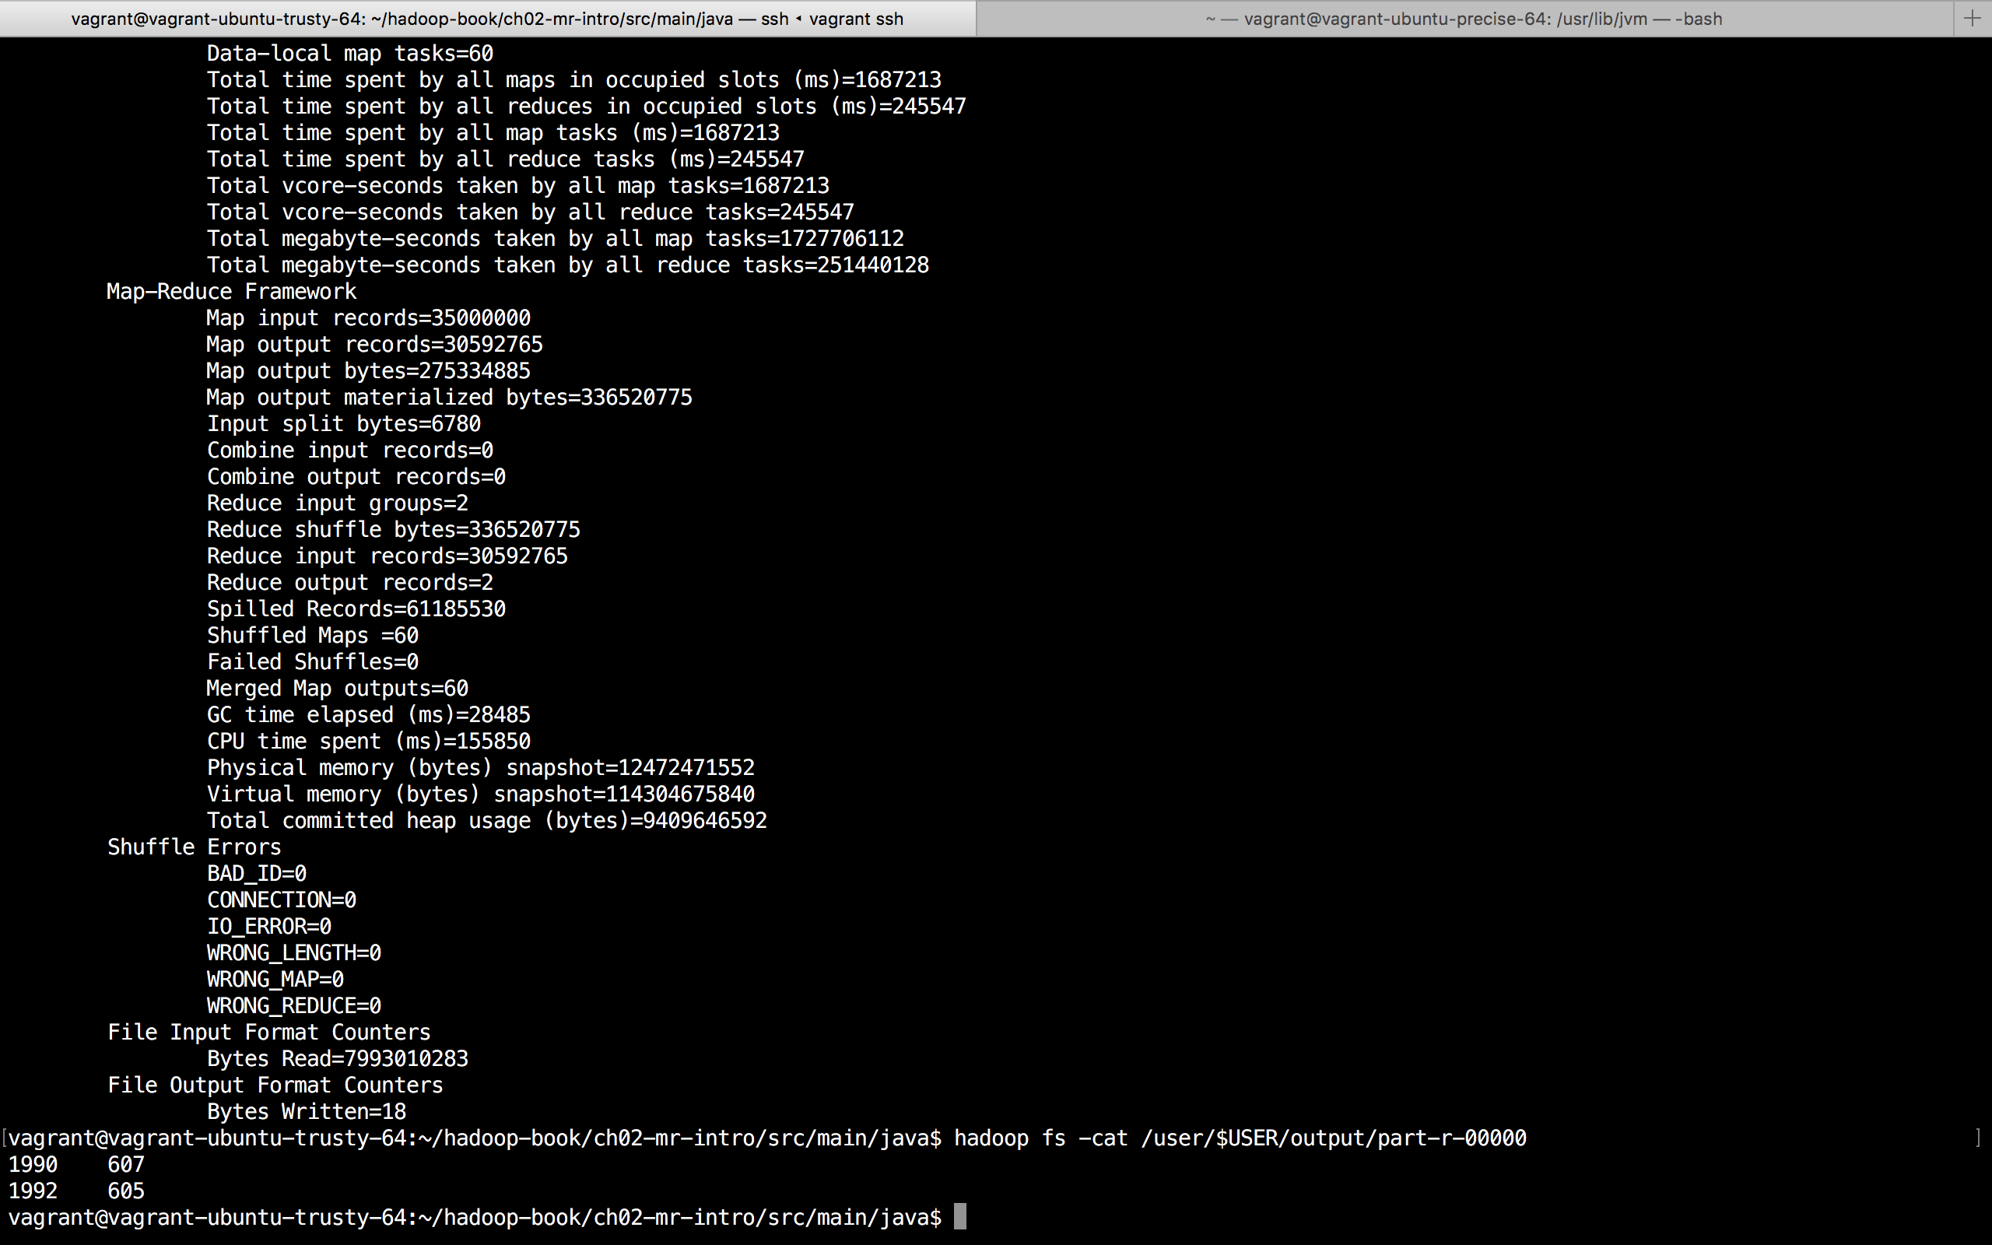

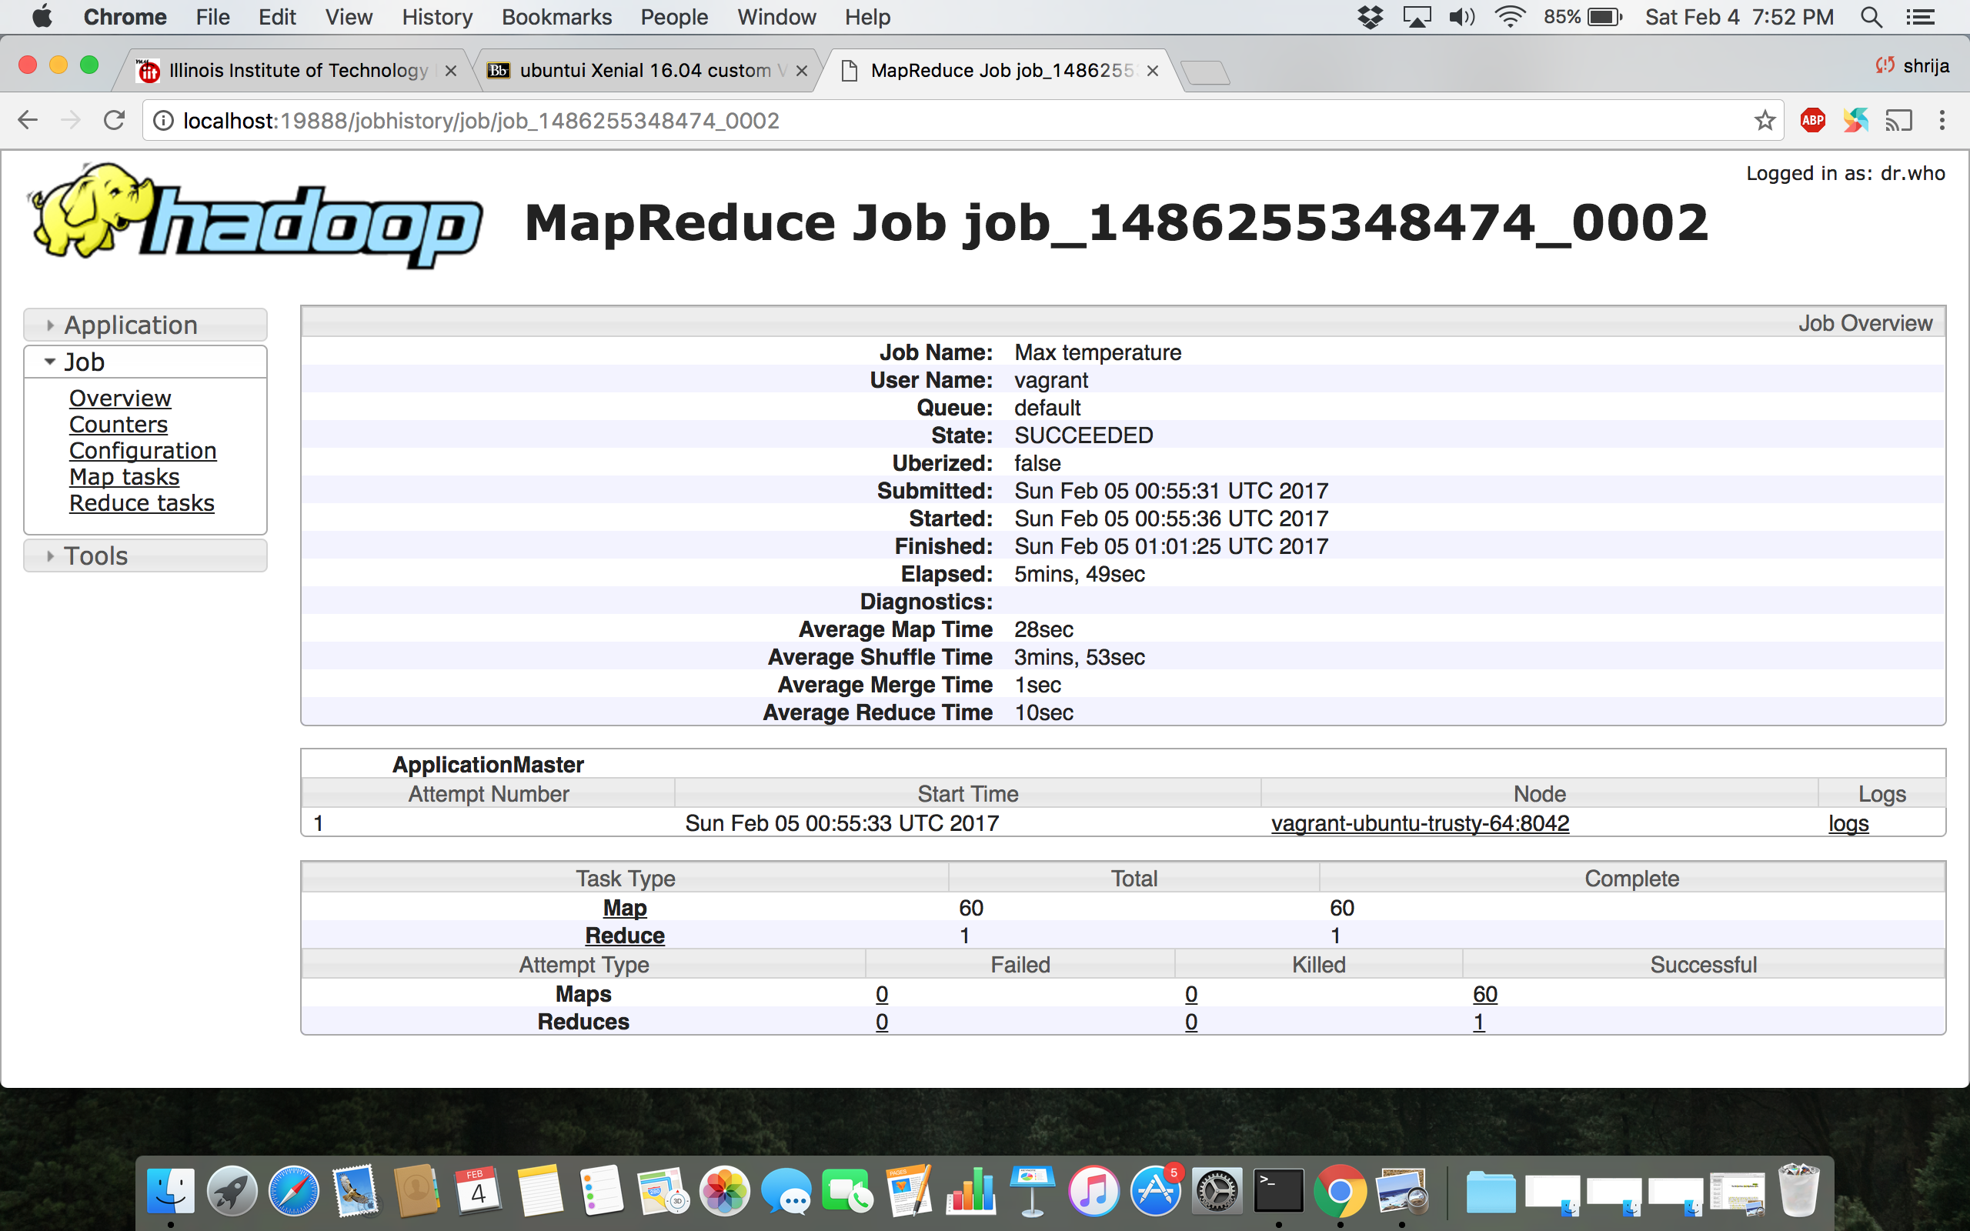

**1990 to 1993 Dataset**

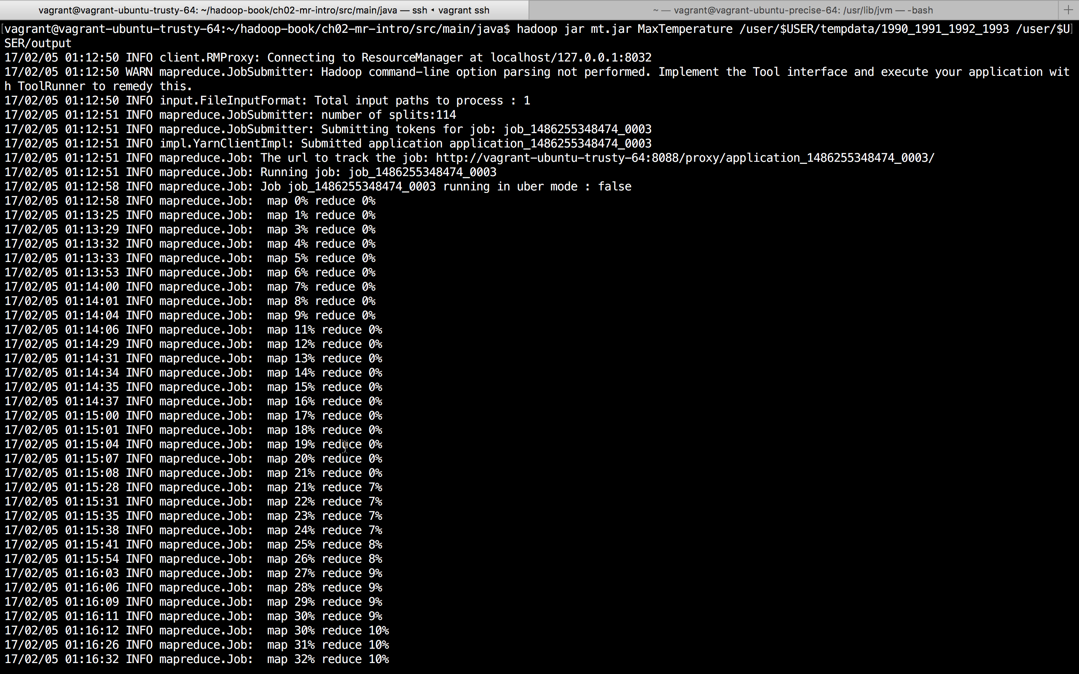

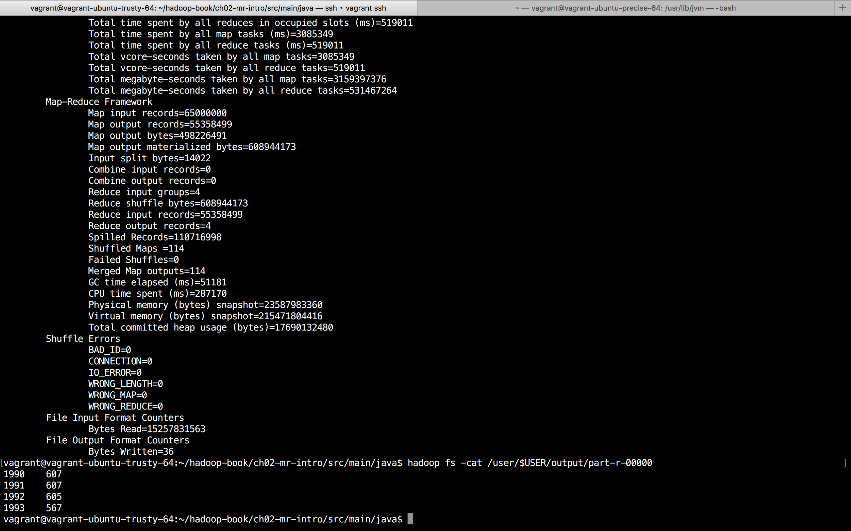

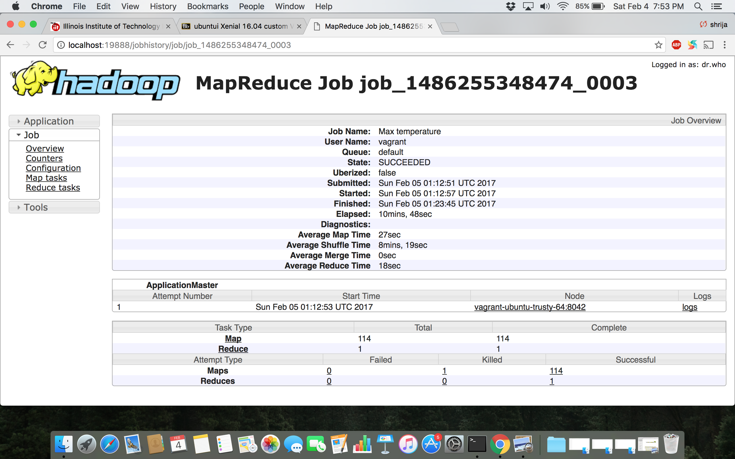

**Using MaxTemperatureWithCombiner:**

**1990 Dataset**

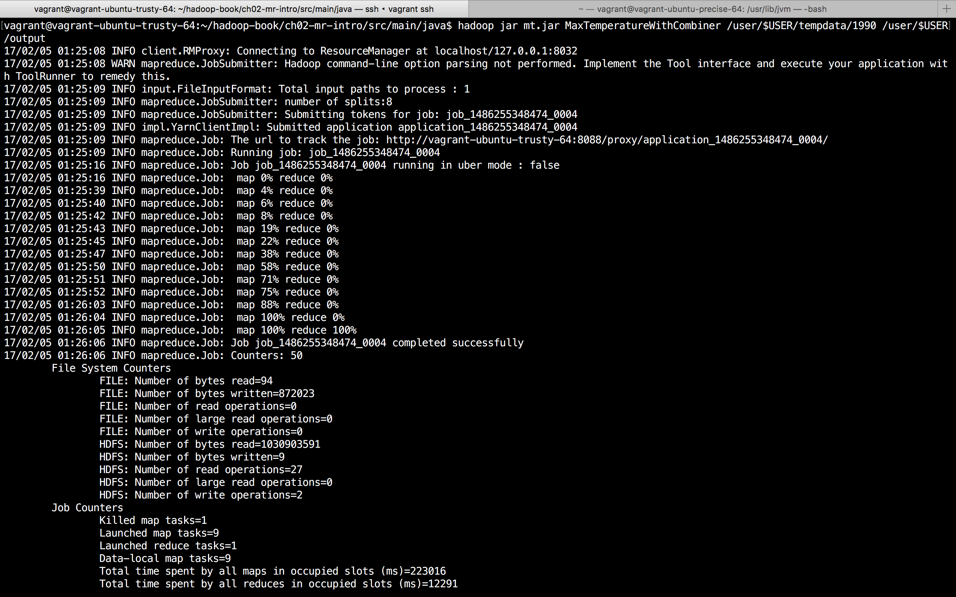

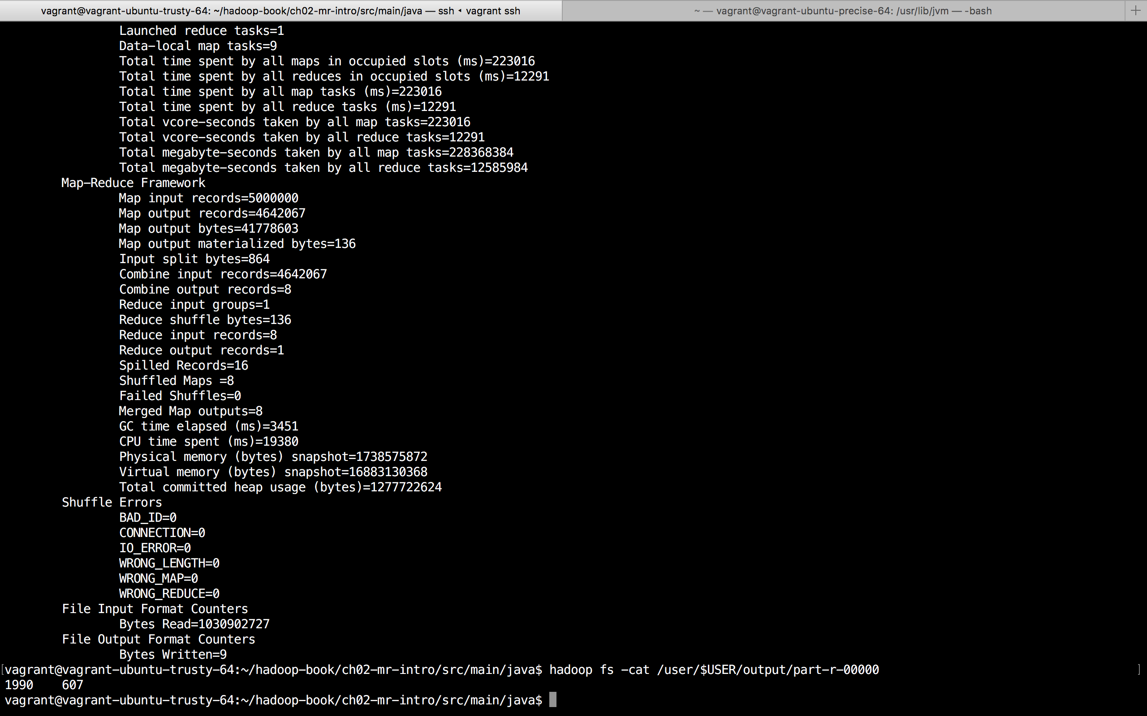

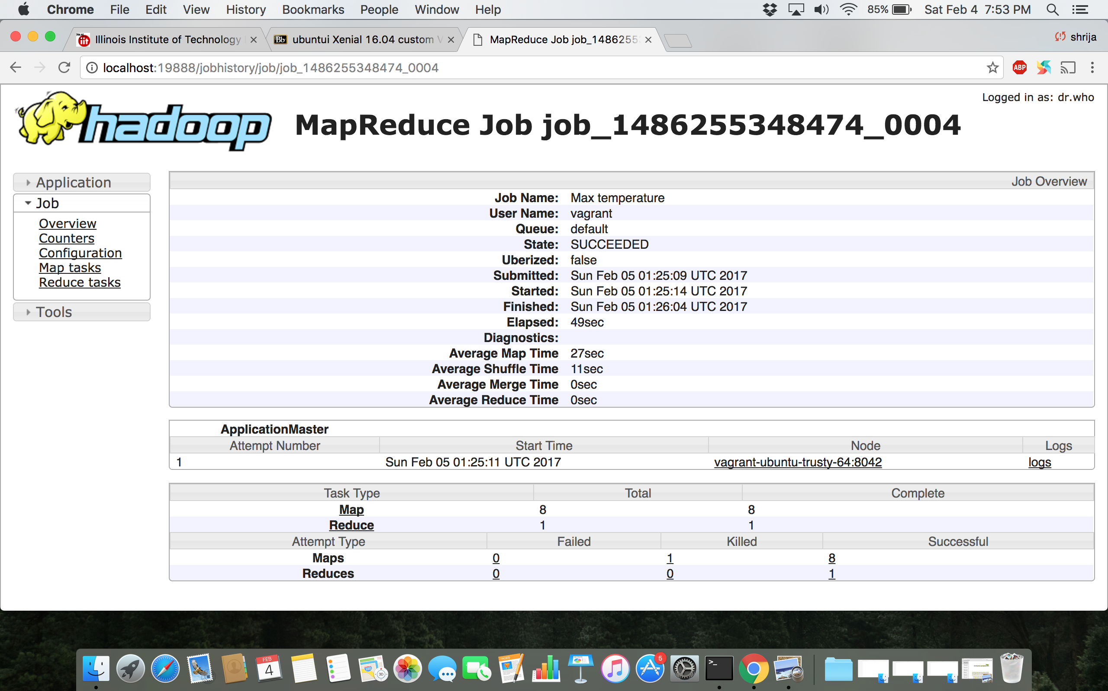

**1990 and 1992 Dataset**

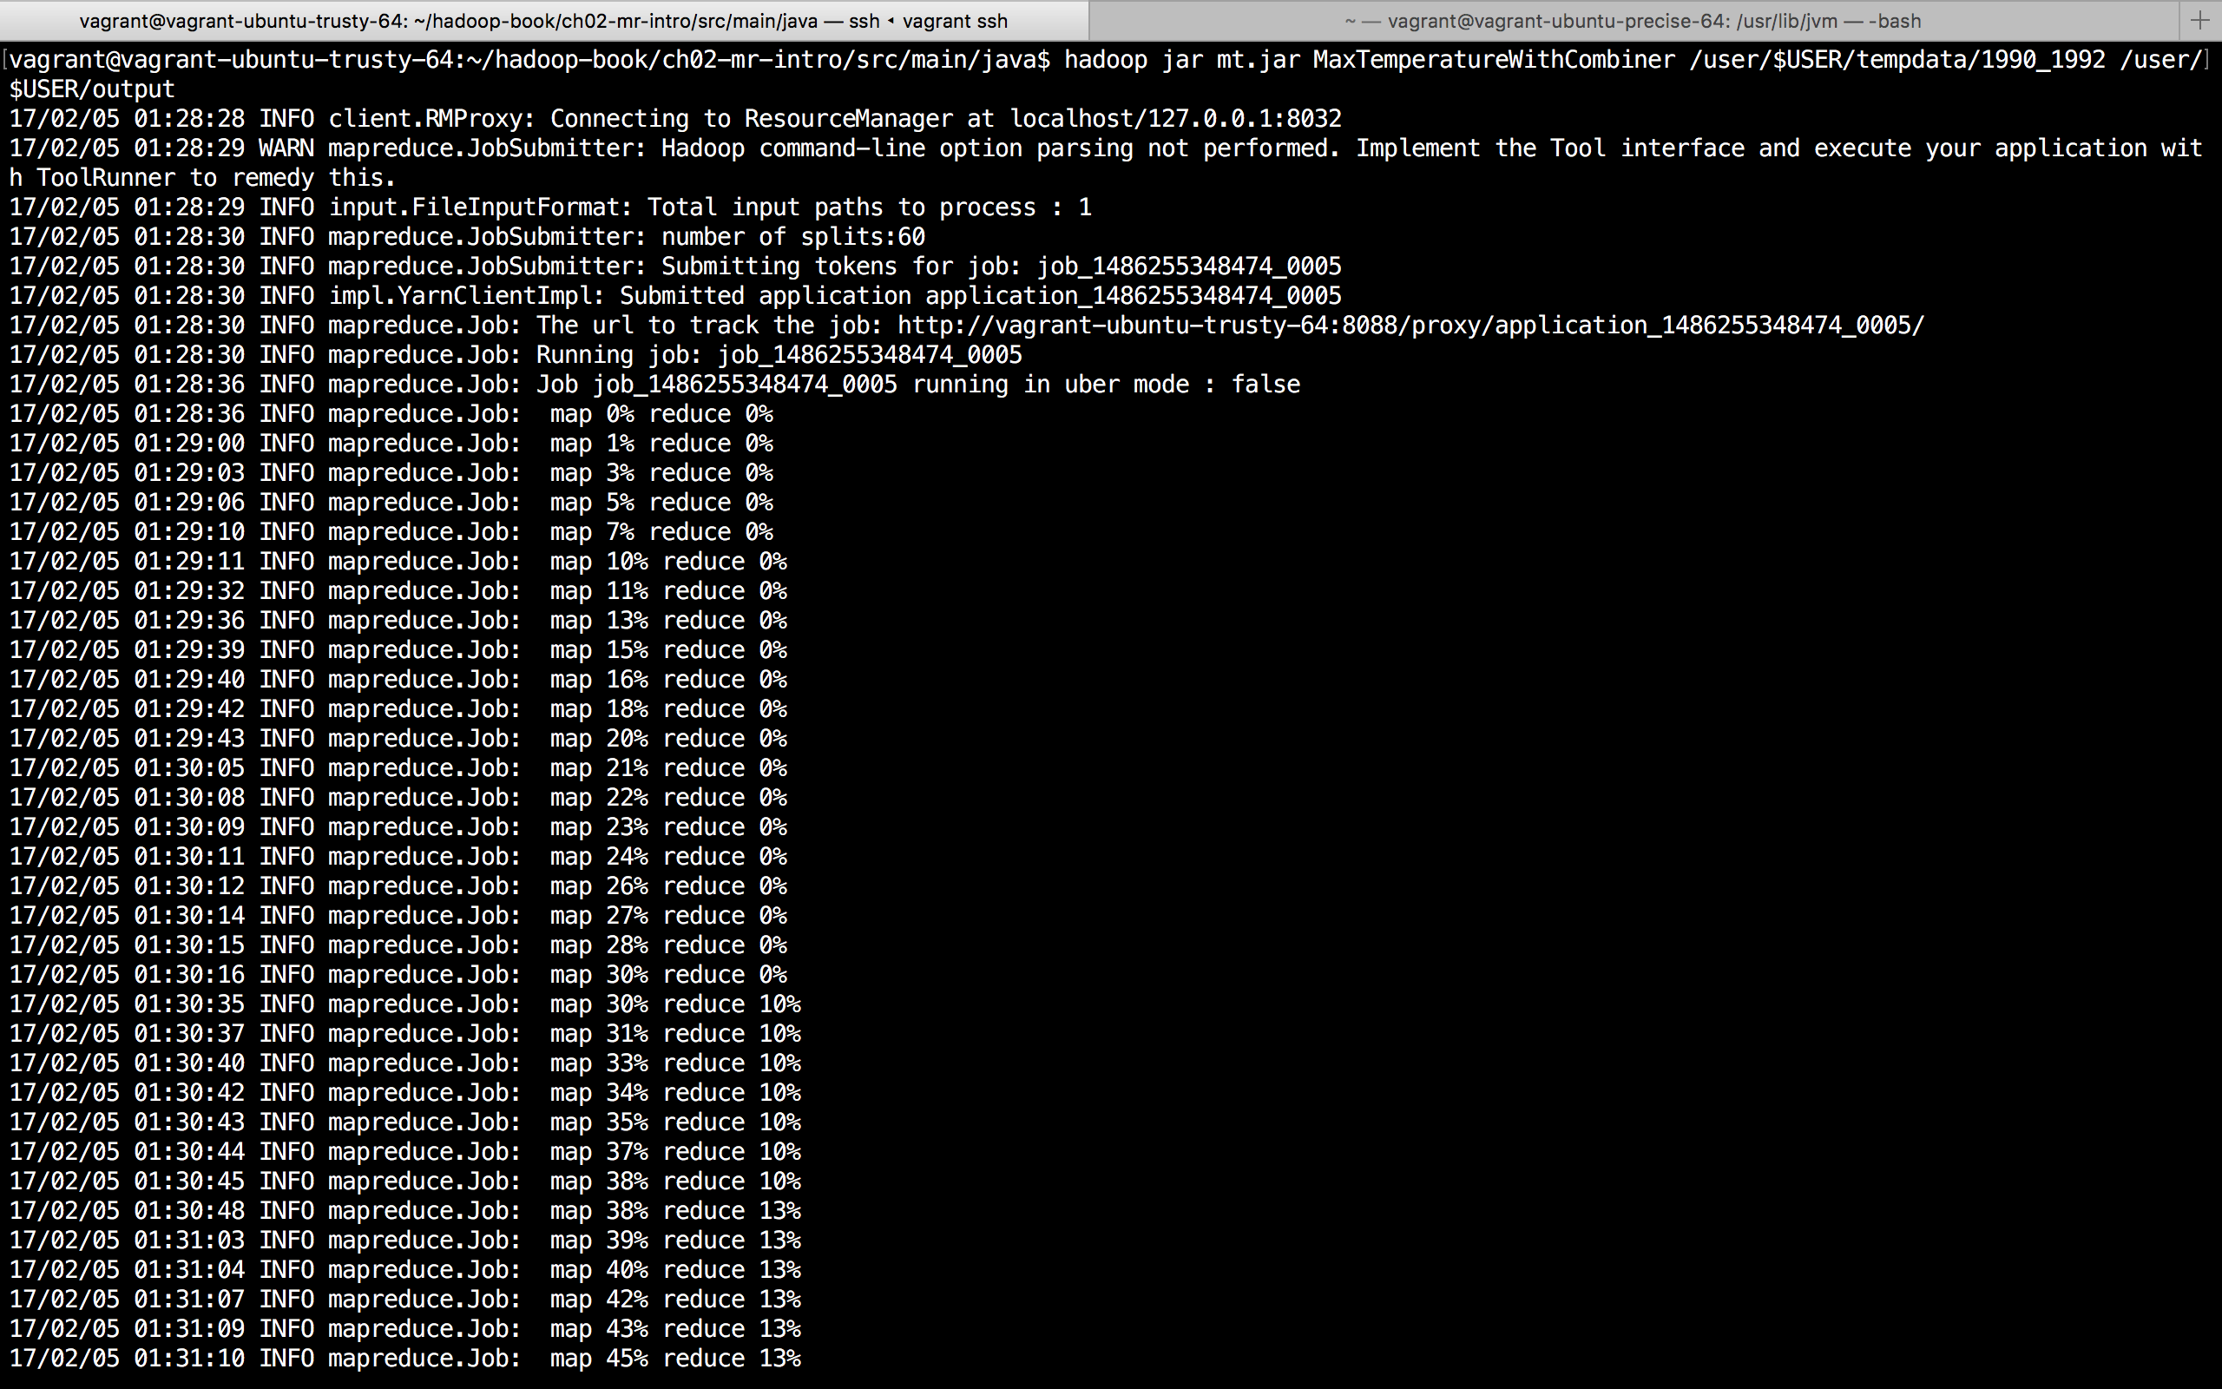

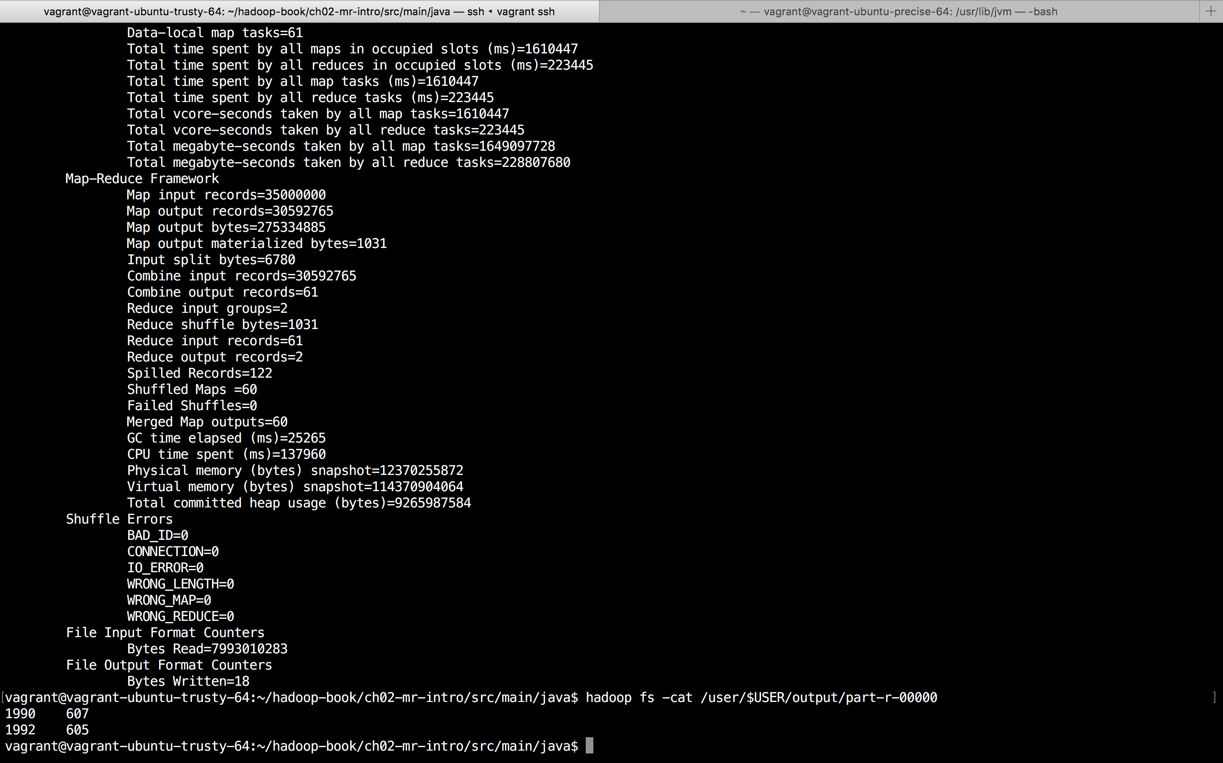

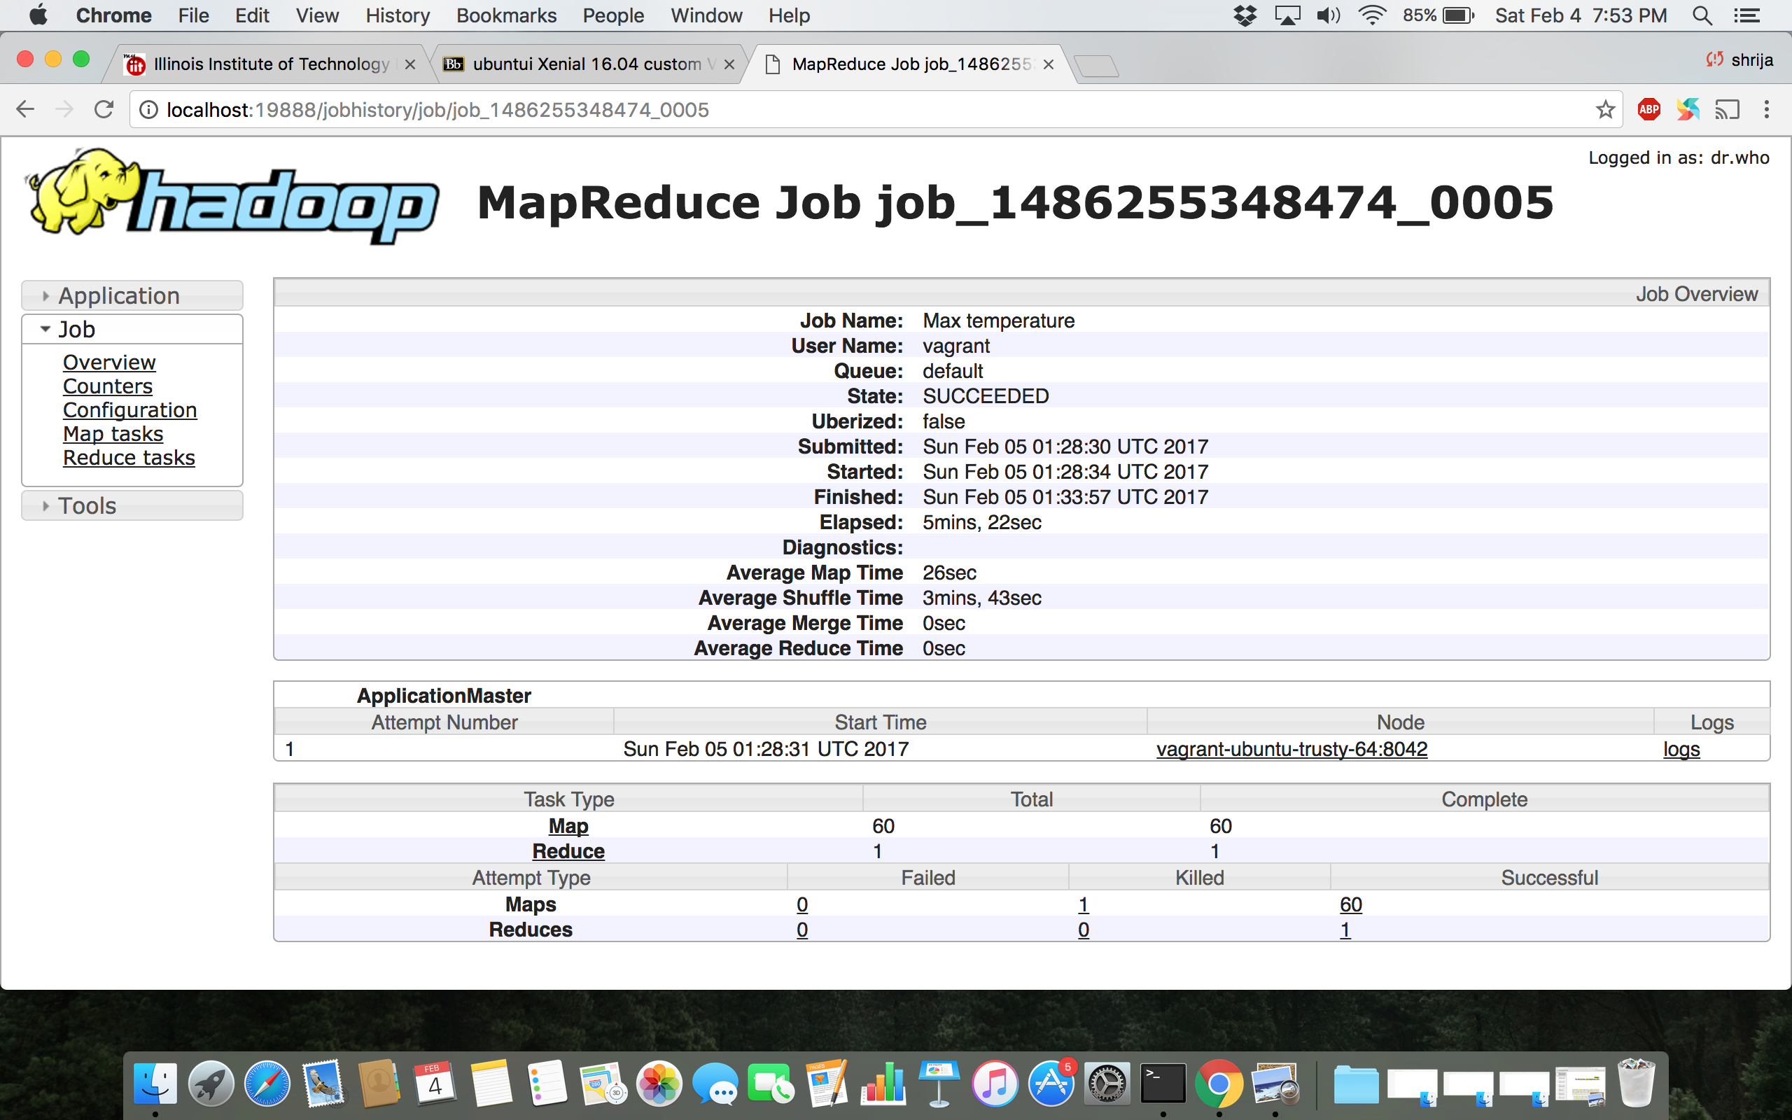

**1990 to 1993 Dataset**

